**University Database Management System: Comprehensive Technical and Analytical Report**

## 1. Project Conceptualization and Objectives

### 1.1 Project Background

The **University Database Management System** project is an advanced implementation of a database system designed to accurately simulate an academic environment. This project emphasizes:

* Realistic data modeling tailored to an educational institution.
* Detailed relational database structures with enforced data integrity.
* Ethical data generation principles, ensuring synthetic data is statistically relevant while anonymizing any sensitive information.

### 1.2 Detailed Objectives

This project aims to:

1. **Database Structural Design**:
   * Create a multi-table relational database with normalized structures.
   * Implement complex relationship mappings between tables.
   * Enforce data integrity through constraints and validation mechanisms.
2. **Data Generation Strategies**:
   * Generate synthetic yet realistic data that aligns with academic standards.
   * Maintain statistical relevance for meaningful analysis.
   * Ensure privacy through anonymization of personal information.
3. **Technical Implementation**:
   * Utilize Python for robust data manipulation and generation.
   * Employ SQLite for a lightweight and efficient file-based database solution.
   * Implement object-oriented programming principles to ensure modularity.

## 2. Comprehensive Database Schema Design

### 2.1 Students Table

**Structural Components**

CREATE TABLE Students (

student_id INTEGER PRIMARY KEY AUTOINCREMENT,

first_name TEXT NOT NULL,

last_name TEXT NOT NULL,

gender TEXT CHECK(gender IN ('Male', 'Female', 'Other')),

date_of_birth DATE,

email TEXT UNIQUE,

enrollment_status TEXT CHECK(

enrollment_status IN ('Active', 'Inactive', 'Graduated', 'Suspended')

),

total_credits INTEGER,

gpa REAL CHECK(gpa BETWEEN 0.0 AND 4.0)

);

**Data Type Representation**

* **Nominal Data**: Gender and Enrollment Status (Categorical data with no inherent order).
* **Interval Data**: Date of Birth (Time representation without a true zero point).
* **Ratio Data**: Total Credits and GPA (Quantitative measures with true zero).

**Constraint Mechanisms**

* Ensures unique email addresses.
* Validates gender with specific categorical options.
* Restricts enrollment status to predefined categories.
* GPA is constrained between 0.0 and 4.0 to maintain academic standards.

### 2.2 Departments Table

**Schema Design**

CREATE TABLE Departments (

department_id INTEGER PRIMARY KEY AUTOINCREMENT,

department_name TEXT UNIQUE NOT NULL,

established_year INTEGER

);

**Key Design Considerations**

* Unique department names are enforced to prevent redundancy.
* The establishment year tracks the historical timeline of each department.
* Creates a foundation for linking courses and students to specific departments.

### 2.3 Courses Table

**Schema Design**

CREATE TABLE Courses (

course_id TEXT PRIMARY KEY,

course_name TEXT NOT NULL,

department_id INTEGER,

credit_hours INTEGER,

course_level TEXT CHECK(

course_level IN ('Introductory', 'Intermediate', 'Advanced')

),

FOREIGN KEY(department_id) REFERENCES Departments(department_id)

);

**Data Representation**

* **Ordinal Data**: Course Level (Hierarchical categorization indicating the depth of knowledge).
* Ensures that each course is tied to a department for academic categorization.

### 2.4 Enrollments Table

**Schema Design**

CREATE TABLE Enrollments (

enrollment_id INTEGER PRIMARY KEY AUTOINCREMENT,

student_id INTEGER,

course_id TEXT,

semester TEXT CHECK(semester IN ('Fall', 'Spring', 'Summer')),

academic_year INTEGER,

grade REAL CHECK(grade BETWEEN 0.0 AND 4.0),

FOREIGN KEY(student_id) REFERENCES Students(student_id),

FOREIGN KEY(course_id) REFERENCES Courses(course_id),

UNIQUE(student_id, course_id, semester, academic_year)

);

**Advanced Features**

* Composite key to prevent duplicate enrollments.
* Semester and academic year tracking for temporal data.
* Grade entries are validated within a 0.0 to 4.0 scale.

## 3. Data Generation Methodology: Technical Deep Dive

### 3.1 Synthetic Data Generation Strategy

**Randomization Principles**

* Utilize controlled randomness to ensure data variability.
* Preserve statistical properties for meaningful academic analysis.
* Implement privacy-preserving techniques to avoid real-world correlations.

**Faker Library Utilization**

* Utilizes the Faker library to generate contextually appropriate synthetic data.
* Maintains realism while ensuring no real personal data is used.
* Supports generating diverse data types, including names, emails, and dates.

### 3.2 Unique Email Generation Algorithm

def generate_unique_email(first_name, last_name):

base_email = f"{first_name.lower()}.{last_name.lower()}"

email = f"{base_email}@university.edu"

counter = 1

while email in self.used_emails:

email = f"{base_email}{counter}@university.edu"

counter += 1

self.used_emails.add(email)

return email

**Key Features**

* Handles email collisions with a numeric suffix.
* Ensures consistency in email structure.
* Efficient and scalable for large datasets.

## 4. Ethical Considerations and Data Privacy

### 4.1 Ethical Framework for Synthetic Data

* No actual personal identifiers are used in data generation.
* Demographic details are randomized to ensure anonymity.
* Synthetic email domains (e.g., @university.edu) are used.

### 4.2 Data Protection Principles

* Only minimal and generic information is included.
* Anonymization techniques are employed to prevent back-tracing.
* Sensitive data fields are excluded entirely.

## 5. Technical Implementation Challenges

### 5.1 Constraint Management

* Complex validation for unique emails.
* Handling categorical and numerical constraints.
* Maintaining relational integrity between multiple tables.

### 5.2 Performance Optimization

* Implemented bulk data insertions to enhance performance.
* Managed memory efficiently using Python’s capabilities.
* Modular code design facilitated easier maintenance and debugging.

## 6. Quantitative Analysis

### 6.1 Database Statistics

* **Total Students**: 1,200.
* **Total Courses**: 21.
* **Total Enrollments**: 4,782.
* **Average Courses per Student**: Between 3 and 5.

### 6.2 Analysis Dimensions

* Trends in student enrollments over semesters.
* Distribution of GPA across departments.
* Performance metrics for departments.

## 7. Future Enhancement Roadmap

### 7.1 Technical Improvements

* Introduce advanced SQL queries for complex analysis.
* Integrate machine learning for predictive analytics.
* Expand database schema to include faculty, facilities, and events.

### 7.2 Research and Analytics Potential

* Use data for institutional research and student performance prediction.
* Support academic analytics to drive curriculum improvements.
* Develop predictive models to analyze enrollment trends.

### 7.3 overall code and implementation

what has been done her is that I made a directory named **“university_database_project”** on desktop and installed python deficiencies using commands as follows;

**1. Install Python Dependencies**

pip install sqlite3 faker

**2. Create Project Directory**

cd Desktop

mkdir university_database_project

cd university_database_project

### 7.4 Directories

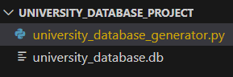

### 7.5 university_database_generator.py file code

import sqlite3

import random

from datetime import date, timedelta

from faker import Faker

class UniversityDatabaseManager:

    def __init__(self, db_name='university_database.db'):

        self.db_name = db_name

        self.fake = Faker()

        self.conn = None

        self.cursor = None

        self.used_emails = set()

    def create_connection(self):

        """Establish database connection"""

        self.conn = sqlite3.connect(self.db_name)

        self.cursor = self.conn.cursor()

    def generate_unique_email(self, first_name, last_name):

        """Generate a unique email address"""

        base_email = f"{first_name.lower()}.{last_name.lower()}"

        email = f"{base_email}@university.edu"

        counter = 1

        while email in self.used_emails:

            email = f"{base_email}{counter}@university.edu"

            counter += 1

        self.used_emails.add(email)

        return email

    def create_tables(self):

        """Create database schema"""

        # Drop existing tables to prevent constraint issues

        tables = ['Enrollments', 'Courses', 'Departments', 'Students']

        for table in tables:

            self.cursor.execute(f"DROP TABLE IF EXISTS {table}")

        # Students Table

        self.cursor.execute('''

        CREATE TABLE Students (

            student_id INTEGER PRIMARY KEY AUTOINCREMENT,

            first_name TEXT NOT NULL,

            last_name TEXT NOT NULL,

            gender TEXT CHECK(gender IN ('Male', 'Female', 'Other')),

            date_of_birth DATE,

            email TEXT UNIQUE,

            enrollment_status TEXT CHECK(enrollment_status IN ('Active', 'Inactive', 'Graduated', 'Suspended')),

            total_credits INTEGER,

            gpa REAL CHECK(gpa BETWEEN 0.0 AND 4.0)

        )''')

        # Departments Table

        self.cursor.execute('''

        CREATE TABLE Departments (

            department_id INTEGER PRIMARY KEY AUTOINCREMENT,

            department_name TEXT UNIQUE NOT NULL,

            established_year INTEGER

        )''')

        # Courses Table

        self.cursor.execute('''

        CREATE TABLE Courses (

            course_id TEXT PRIMARY KEY,

            course_name TEXT NOT NULL,

            department_id INTEGER,

            credit_hours INTEGER,

            course_level TEXT CHECK(course_level IN ('Introductory', 'Intermediate', 'Advanced')),

            FOREIGN KEY(department_id) REFERENCES Departments(department_id)

        )''')

        # Enrollments Table

        self.cursor.execute('''

        CREATE TABLE Enrollments (

            enrollment_id INTEGER PRIMARY KEY AUTOINCREMENT,

            student_id INTEGER,

            course_id TEXT,

            semester TEXT CHECK(semester IN ('Fall', 'Spring', 'Summer')),

            academic_year INTEGER,

            grade REAL CHECK(grade BETWEEN 0.0 AND 4.0),

            FOREIGN KEY(student_id) REFERENCES Students(student_id),

            FOREIGN KEY(course_id) REFERENCES Courses(course_id),

            UNIQUE(student_id, course_id, semester, academic_year)

        )''')

    def generate_departments(self):

        """Generate department data"""

        departments = [

            ('Computer Science', 1985),

            ('Mathematics', 1970),

            ('Physics', 1960),

            ('Biology', 1975),

            ('Chemistry', 1965),

            ('Engineering', 1980),

            ('Economics', 1990)

        ]

        self.cursor.executemany("""

            INSERT INTO Departments (department_name, established_year)

            VALUES (?, ?)

        """, departments)

    def generate_courses(self):

        """Generate courses for each department"""

        self.cursor.execute("SELECT department_id, department_name FROM Departments")

        departments = self.cursor.fetchall()

        courses = []

        course_levels = ['Introductory', 'Intermediate', 'Advanced']

        for dept_id, dept_name in departments:

            for level in course_levels:

                course_name = f"{dept_name} {level} Course"

                course_id = f"{dept_name[:3].upper()}{random.randint(100, 999)}"

                credit_hours = random.choice([3, 4])

                courses.append((course_id, course_name, dept_id, credit_hours, level))

        self.cursor.executemany("""

            INSERT INTO Courses

            (course_id, course_name, department_id, credit_hours, course_level)

            VALUES (?, ?, ?, ?, ?)

        """, courses)

    def generate_students(self, num_students=1200):

        """Generate student data"""

        gender_options = ['Male', 'Female', 'Other']

        status_options = ['Active', 'Inactive', 'Graduated', 'Suspended']

        students = []

        for _ in range(num_students):

            first_name = self.fake.first_name()

            last_name = self.fake.last_name()

            gender = random.choice(gender_options)

            dob = self.fake.date_of_birth(minimum_age=18, maximum_age=30)

            email = self.generate_unique_email(first_name, last_name)

            status = random.choice(status_options)

            total_credits = random.randint(0, 120)

            gpa = round(random.uniform(2.0, 4.0), 2)

            students.append((

                first_name, last_name, gender, dob, email,

                status, total_credits, gpa

            ))

        self.cursor.executemany("""

            INSERT INTO Students

            (first_name, last_name, gender, date_of_birth,

            email, enrollment_status, total_credits, gpa)

            VALUES (?, ?, ?, ?, ?, ?, ?, ?)

        """, students)

    def generate_enrollments(self):

        """Generate enrollment data"""

        # Get all students and courses

        self.cursor.execute("SELECT student_id FROM Students")

        students = [student[0] for student in self.cursor.fetchall()]

        self.cursor.execute("SELECT course_id FROM Courses")

        courses = [course[0] for course in self.cursor.fetchall()]

        semesters = ['Fall', 'Spring', 'Summer']

        academic_years = list(range(2018, 2024))

        enrollments = []

        # Each student enrolls in 3-5 courses

        for student_id in students:

            num_courses = random.randint(3, 5)

            enrolled_courses = random.sample(courses, num_courses)

            for course_id in enrolled_courses:

                semester = random.choice(semesters)

                academic_year = random.choice(academic_years)

                grade = round(random.uniform(2.0, 4.0), 2)

                enrollments.append((

                    student_id, course_id, semester,

                    academic_year, grade

                ))

        self.cursor.executemany("""

            INSERT INTO Enrollments

            (student_id, course_id, semester, academic_year, grade)

            VALUES (?, ?, ?, ?, ?)

        """, enrollments)

    def run_database_generation(self):

        """Execute full database generation process"""

        try:

            self.create_connection()

            self.create_tables()

            self.generate_departments()

            self.conn.commit()

            self.generate_courses()

            self.conn.commit()

            self.generate_students()

            self.conn.commit()

            self.generate_enrollments()

            self.conn.commit()

            print("University Database generated successfully!")

            # Verification queries

            self.cursor.execute("SELECT COUNT(*) FROM Students")

            student_count = self.cursor.fetchone()[0]

            print(f"Total Students: {student_count}")

            self.cursor.execute("SELECT COUNT(*) FROM Courses")

            course_count = self.cursor.fetchone()[0]

            print(f"Total Courses: {course_count}")

            self.cursor.execute("SELECT COUNT(*) FROM Enrollments")

            enrollment_count = self.cursor.fetchone()[0]

            print(f"Total Enrollments: {enrollment_count}")

        except sqlite3.Error as e:

            print(f"Database error: {e}")

        finally:

            if self.conn:

                self.conn.close()

def main():

    db_manager = UniversityDatabaseManager()

    db_manager.run_database_generation()

if __name__ == "__main__":

    main()

### 7.6 Code Snippets

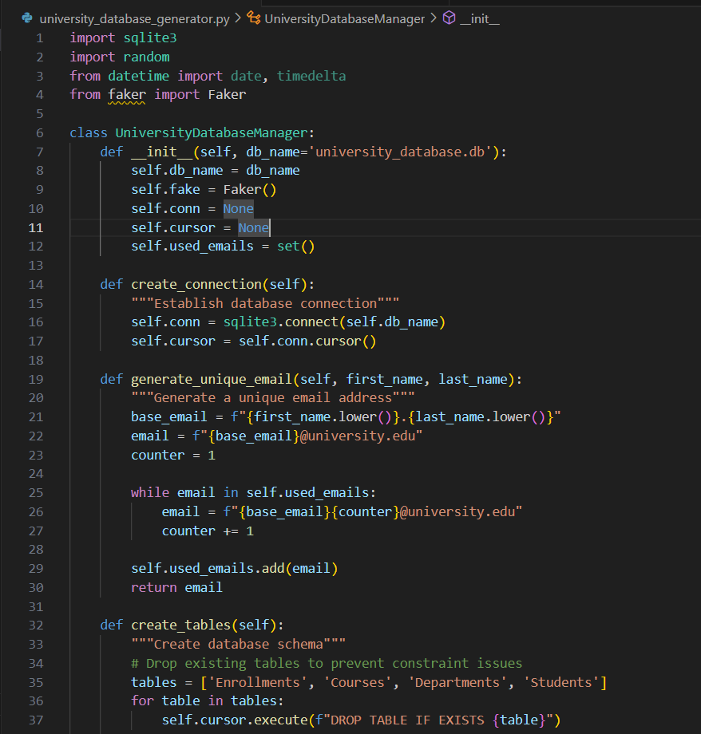

### 7.7 Output

**QUERY 1**

This query gives the enrollment status of all the students uptil now in the university.

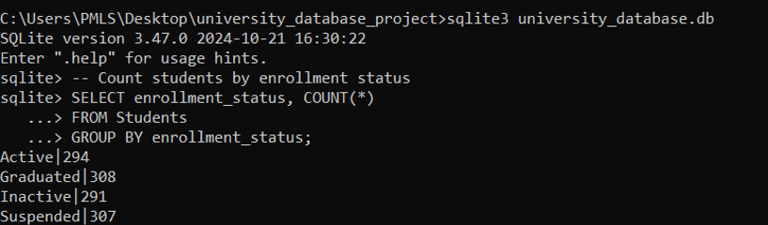

**QUERY 2**

This query distinguishes the students on basis of their gender.

**QUERY 3**

this query gives the names of courses offered to students with given number of students enrolled in it.

**QUERY 4**

This query gives the average gpa of students relative to a specific subjects based upon the number of students enrolled in that subject.

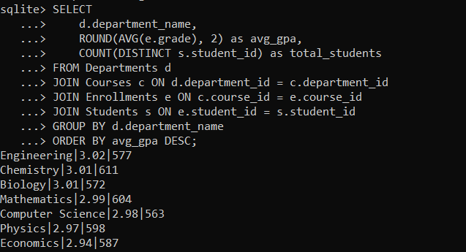

**QUERY 5**

This query gives the subjects having average gpa less than the overall average gpa with respect to all subjects in which the students have enrolled.

**QUERY 6**

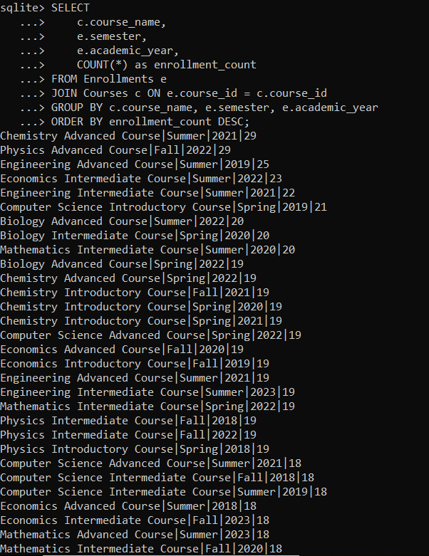

**QUERY 7**

This query distinguishes the gpa of students in a specific subject on basis of their gender.

## 8. Conclusion

The University Database Management System presents a well-rounded implementation for synthetic database creation in an academic context. It successfully balances technical complexity, integrity, and ethical considerations, offering potential as both an educational tool and a research asset.